BIOLOGY PRACTICAL PAPER 2 2026 UNEB PROPOSED GUIDE BY DR TUSHABE DERRICK
Tel::0766985583

ITEM 1

(a) Aim, hypothesis, variables and apparatus/materials

Aim
To investigate the food nutrients present in drinks X, Y and Z using appropriate food tests and determine which drink should be given to the participant to provide readily available energy and support muscle development.

Hypothesis
Drink X contains glucose, which provides readily available energy; drink Y contains proteins, which support growth and muscle repair; and drink Z contains starch, which can be digested to provide energy.

Variables
- Independent variable: The type of drink tested (X, Y or Z).
- Dependent variable: The colour change or precipitate produced after adding the appropriate food-test reagent.
- Controlled variables: The volume of each drink tested, the volume and concentration of each reagent, the heating temperature and duration during Benedict’s test, and the cleanliness of the apparatus.

Apparatus and materials
- Solutions X, Y and Z.
- Test tubes and a test-tube rack.
- Iodine solution.
- Benedict’s solution.
- Sodium hydroxide solution.
- Dilute copper(II) sulphate solution, or Biuret reagent.
- Droppers.
- Measuring cylinder.
- Boiling tubes.
- Heat source and hot-water bath.
- Thermometer.
- Distilled water.

(b) Procedures, observations and deductions(Check at the back of this document)

(c) Recommendation to the participant
The participant should be given drink X to provide readily available energy and drink Y to supply protein for muscle growth and repair.
Drink X contains glucose, which can be absorbed and used in cellular respiration to release energy relatively quickly. This is useful after strenuous physical activity when energy reserves may have been depleted.
Drink Y contains proteins, which provide amino acids needed for the growth, maintenance and repair of muscle tissue.
Drink Z contains starch, which can also provide energy after digestion into simpler sugars. However, glucose in drink X is already a simple sugar and does not require digestion into monosaccharides before absorption.
Therefore, drink X is the most suitable of the three for providing rapidly available energy, while drink Y supports muscle development. These drinks would supplement, not replace, appropriate medical assessment and treatment following a collapse.

ITEM 2: PLANT SPECIMENS J AND K
Specimen J is Bidens pilosa, while specimen K is couch grass

(a)(i) Identify the different plant categories to which specimens J and K belong, giving reasons.

Specimen J: Bidens pilosa
Specimen J belongs to the category of annual plants because it completes its life cycle within one growing season. It germinates, grows, flowers, produces fruits and seeds, and then dies. Its seeds can remain in the soil and germinate when environmental conditions become favourable, causing the plant to appear seasonally.

Specimen K: Couch grass
Specimen K belongs to the category of perennial plants because it lives for several years. Its underground rhizomes survive unfavourable conditions and produce new shoots when conditions become favourable, enabling the plant to persist in the compound throughout the year.

(a)(ii) Explain how structures of specimen K enable it to appear in the compound throughout the year.
- Underground rhizomes: These are horizontal underground stems that remain alive in the soil during unfavourable conditions. They enable couch grass to survive when above-ground shoots die back or growth is reduced.
- Food-storage tissues: The rhizomes store food reserves, which can be used for respiration and the production of new shoots when conditions become favourable.
- Buds on the rhizomes: The buds develop into new shoots when suitable moisture, temperature and other environmental conditions return. This allows the plant to regenerate even when the above-ground parts have been damaged or removed.
- Nodes and internodes: The rhizomes possess nodes and internodes. Nodes bear buds that can develop into shoots, while the elongated internodes allow the rhizomes to spread horizontally through the soil.
- Adventitious roots: Roots develop from the underground stems and absorb water and mineral salts from the soil. They also anchor the plant and help establish new growth.
- Extensive rhizome system: The rhizomes spread through the soil, allowing K to occupy a large area and regenerate from different points. This helps the plant persist even when some parts are damaged.
- Stolons: K can also produce horizontal stems that grow along the soil surface. These can form roots and shoots at their nodes, helping the plant spread and establish new plants.

(b) Draw and label the organ of specimen J responsible for making food. State the magnification of the drawing.
The organ responsible for making food in Bidens pilosa is the leaf.
A drawing of the organ of J responsible for making food.
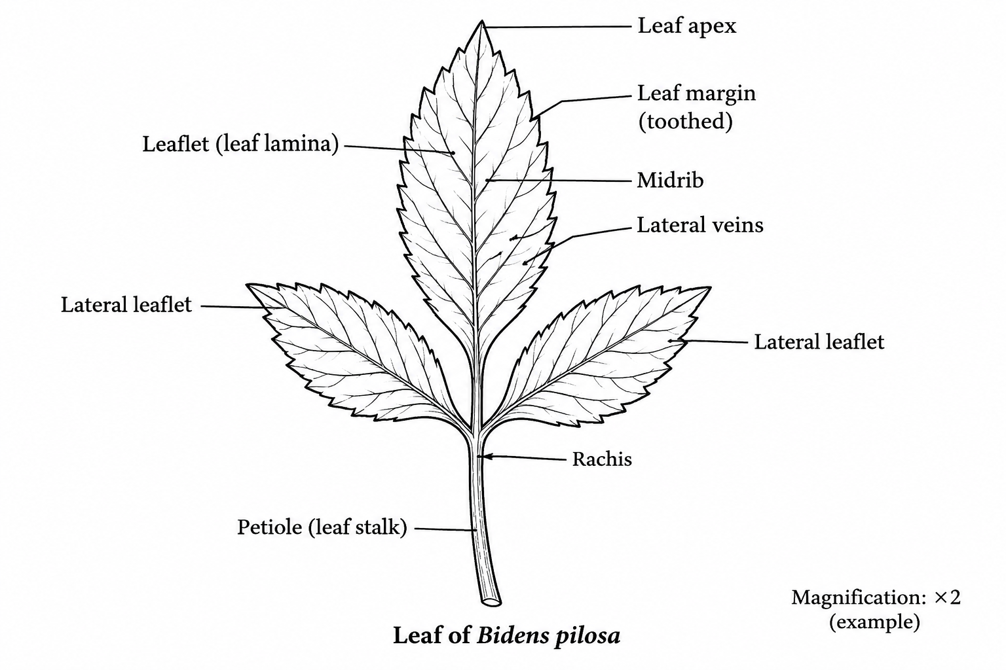
Use the actual specimen supplied in the examination. Bidens pilosa commonly has compound leaves with toothed leaflets, so draw the leaf arrangement and number of leaflets as observed rather than copying an unrelated simple leaf.
Drawing guidance: Make the drawing large and proportionate, use clear continuous outlines, avoid shading, and draw straight label lines that do not cross.
Procedure and results for item 1
Test | Procedure | Solution | Observation | Deduction
Iodine test for starch | To 1 cm³ of solution in a clean test tube, added 2 drops of iodine solution. | X | Turbid solution turned brown. | Starch absent.
Iodine test for starch |  | Y | Turbid solution turned brown. | Starch absent.
Iodine test for starch |  | Z | Turbid solution turned blue-black. | Starch present.
Biuret test for proteins | To 1 cm³ of solution in a clean test tube, added 4 drops of sodium hydroxide solution followed by 2 drops of copper(II) sulphate solution. | X | Turbid solution turned blue which persisted . | Protein absent.
Biuret test for proteins |  | Y | Turbid solution turned to purple precipitate | Protein present.
Biuret test for proteins |  | Z | Turbid solution turned to blue precipitate | Protein absent.
Benedict’s test for reducing sugars | To 1 cm³ of solution in a clean test tube, added 1 cm³ of Benedict’s solution and boil. | X | Turbid solution turned blue, green or yellow, precipitate . | Reducing sugars present.
Benedict’s test for reducing sugars |  | Y | Turbid solution turned blue and persisted. | Reducing sugars absent.
Benedict’s test for reducing sugars |  | Z | Turbid solution turned blue and persisted. | Reducing sugars absent.

